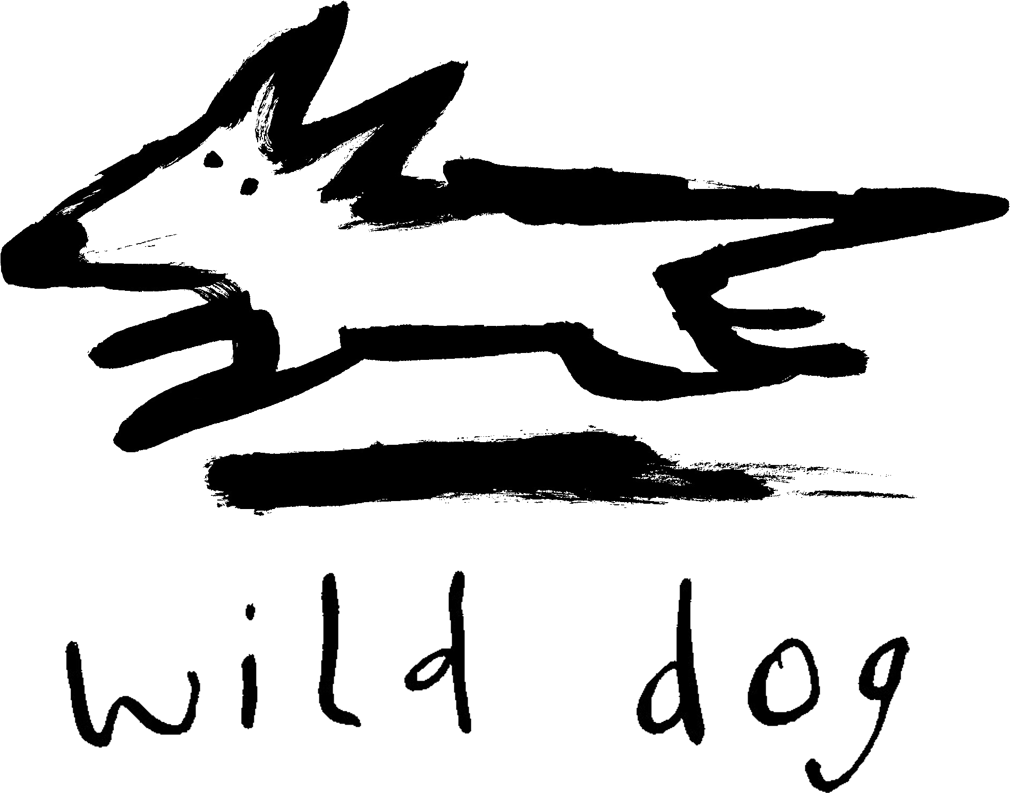

Wild Dog Books

Teachers’ Notes

Kangaroos Oz Animals

Synopsis
Kangaroos are one of the most significant animals in Australian culture. They appear on our currency, our coat of arms, even on our plate! They are a source of national pride–the boxing kangaroo, for example–and an avenue for foreign derision (questions of riding a ‘roo to school spring to mind). To some they are an intrinsic part of the landscape, to others a feral pest. Learn all about these fascinating animals and what makes them uniquely Australian.
Writing style
Oz Animals Kangaroos has been designed with the needs of very early readers and reluctant readers in mind. Text is succinct and simple, with no more than a few sentences on a page. The large format images relate directly to the text, so young readers have multiple entry points to engaging with the information. There is a glossary and index in the back of the book, which will aid young readers in developing the tools of research and analysis.
Photographic style
The Oz Animals series uses photographs that bring the viewer close to the subject that is being discussed. These photographs also have the advantage that the image is static, giving the reader the opportunity to explore the image and look at the subject matter and its features in detail. The photographs are also strongly composed and clearly printed with bright strong colours to increase the appeal to visual readers. Readers can explore how photographs are used to convey messages.
Study notes
Themes:
- Indigenous animals
- Marsupials
- Species
- Habitats
- Food and predators
- Breeding
- Group behaviour
Curriculum link: Literacy
Before reading Oz Animals Kangaroos:
- Brainstorm what students know about kangaroos.
- Ask the students if they have seen a kangaroo. If yes, ask them to describe their appearance and behaviour.
- What is their first response when they look at the cover of the book?

While reading Oz Animals Kangaroos:
- Ask the students to take turns reading a paragraph aloud to the rest of the class. Where appropriate, ask the students what they think certain words may mean.
- Ask the students to keep a table list of the features that help kangaroos live in their environment. In one column put the feature and in the second column write how the feature helps the kangaroo.
Curriculum Theme: Critical and Creative Thinking
After reading Oz Animals Kangaroos ask the students the following questions:
- What type of animal are they?
- Are there different species of kangaroo? What are they?
- What are the special features of kangaroos?
- How are they different from other Australian animals?
- What type of habitat does it live in? How are they suited to this environment?
- What do they eat?
- How do they travel around?
Ask the students to reflect on the words they would use to describe kangaroos and the words that have been used to describe kangaroos. Ask them to draw up a list of words that can be used to describe kangaroos.
Curriculum link: ICT Capability
After reading Oz Animals Kangaroos:
- Organise the class into small groups. Assign each group a different species of kangaroo (Red, Western Grey, Eastern Grey) and ask them to research online. Ask the children to look for information about their species e.g. physical features, their habitat, what they eat. Ask them to print different images that highlight the information they have learnt (colour, habitat, size etc).
- Ask each group to create a poster collage. Ask them to attach the images they found and to write a short descriptive sentence explaining why they chose the picture. All members of the group take turns presenting their findings to the rest of the class.
Curriculum Theme: Personal and Social Capability
After reading Oz Animals Kangaroos:
- Organise the class into two groups. In one group, ask the students to work as a team to construct a word finder puzzle. Ask each student to suggest an appropriate word about kangaroos using words they have learned from the book. (e.g. joey, pouch, stinker etc). Once completed, print copies for the other group to complete.
- In the second group, students should work as a team to create a trivia bingo game. Ask each student to suggest a fact they found surprising or interesting. Combine these facts into a game for the whole class.
Find out more
- http://kids.nationalgeographic.com.au/kids/animals/creaturefeature/kangaroos/
- http://animal.discovery.com/mammals/kangaroo-info.htm
Marketing and promotion
Oz Animals Kangaroos is the first in a new series focusing on Australian animals. It is similar in scope to the successful CloseUp series, which includes Snakes CloseUp, Mini-Beasts CloseUp, Crocs CloseUp, Spiders CloseUp, Wolves CloseUp, Human Body CloseUp, Elephants CloseUp and Sharks CloseUp. Future titles such as Dingoes and Koalas are planned.

