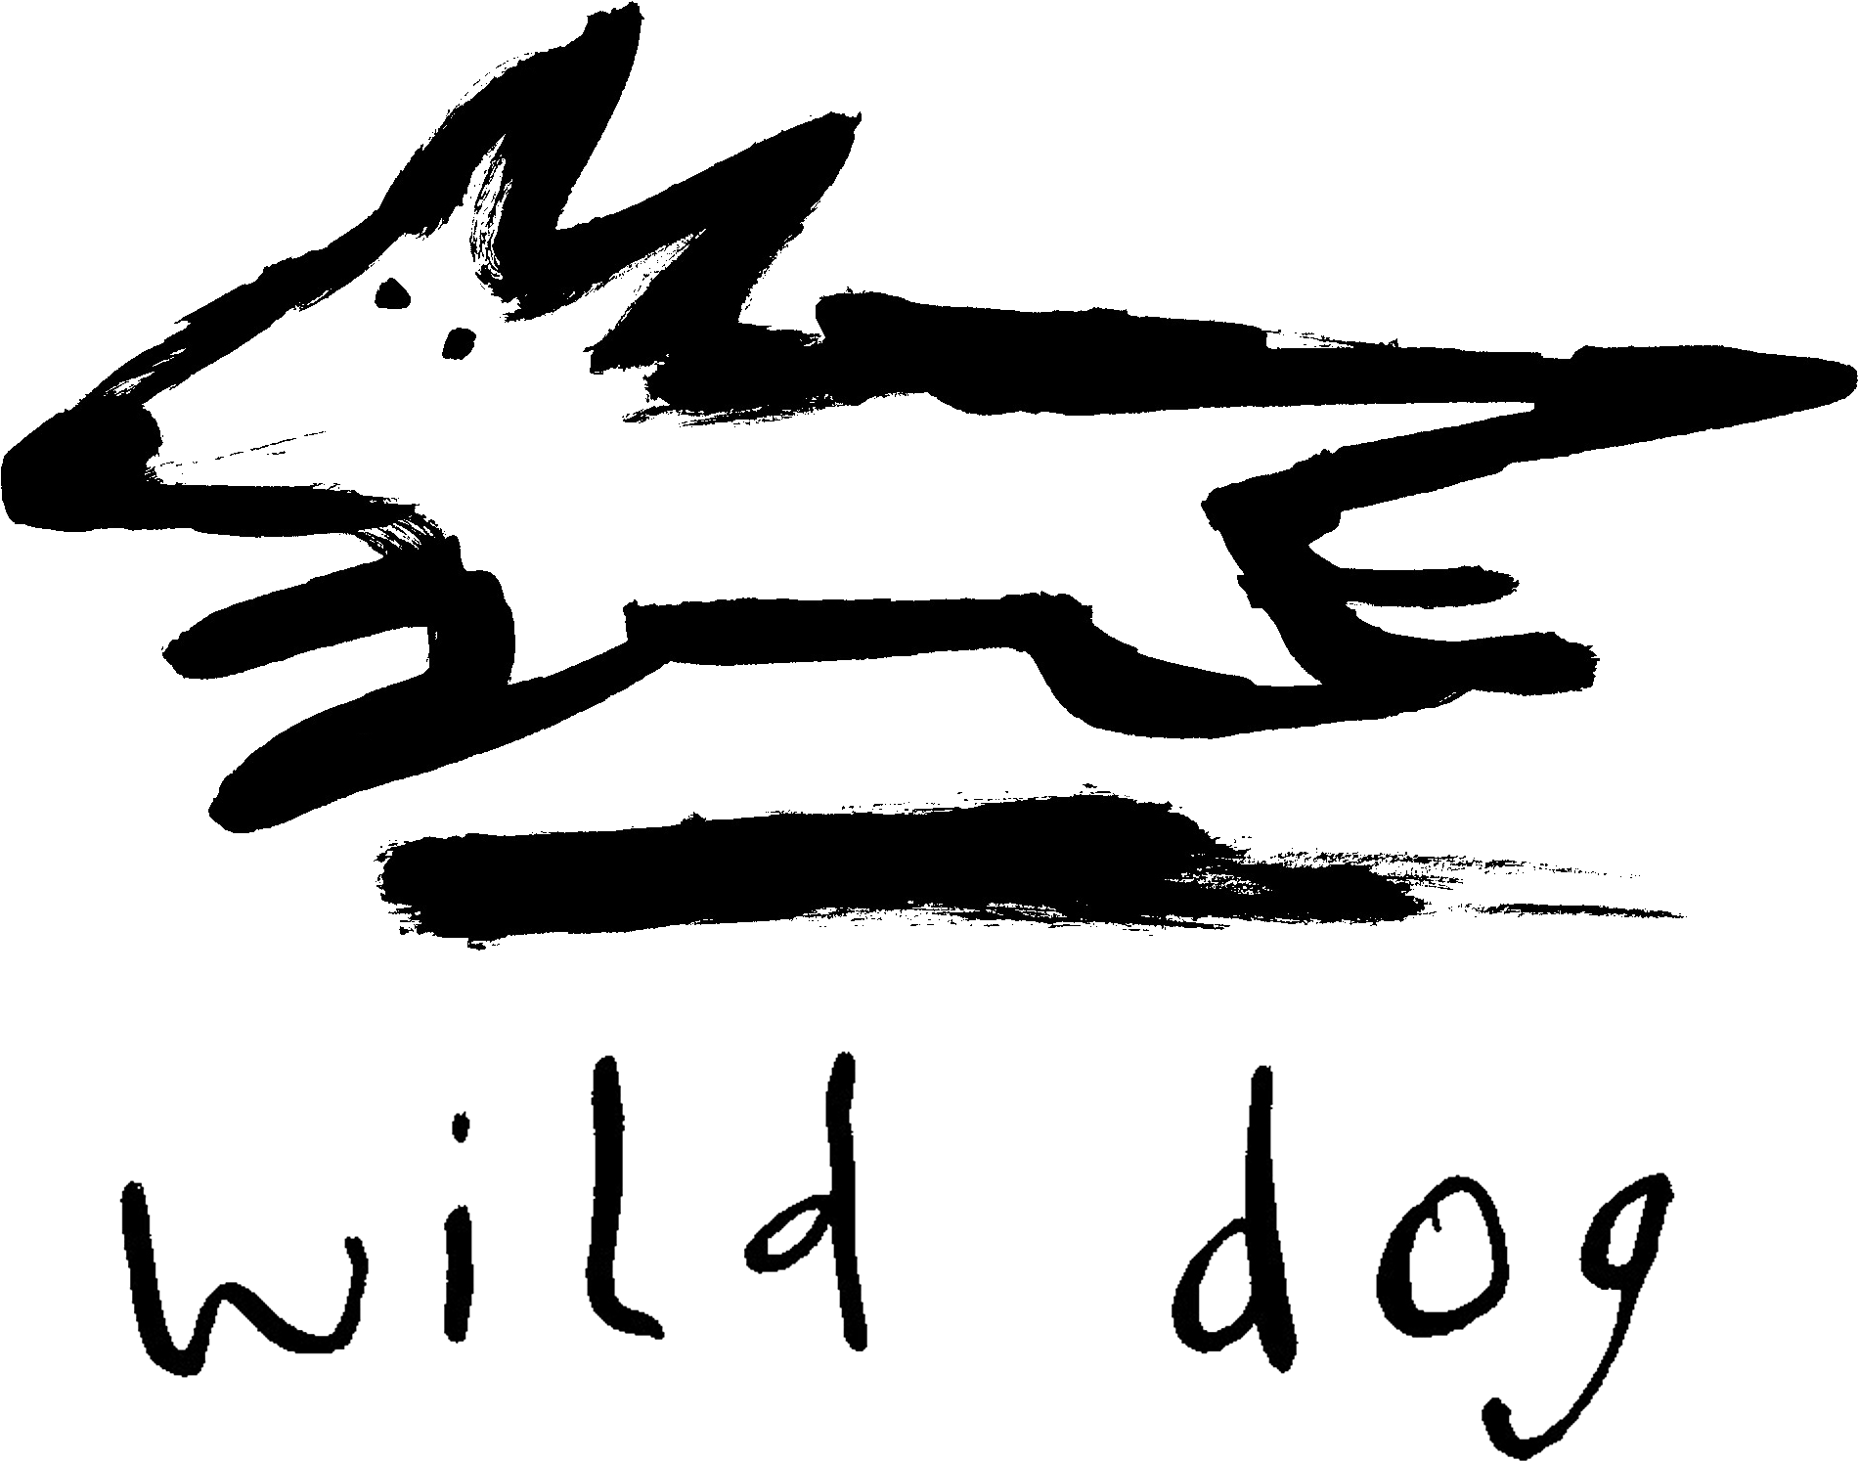

Wild Dog Books

Teachers’ Notes

Ants CloseUp

Synopsis
Ants are among the most intelligent insects on the planet. They live in nests that can be found in trees, underground, in mounds or chewed out of wood. Nests can contain vast numbers of ants, and every ant has a special role to play to keep the colony functioning. The queen is responsible for laying eggs, while worker ants take care of the queen and her offspring, gather food and look after the nest. Some ants protect the colony from danger, while other ants even farm certain insects for their own benefit! Learn all about these wonderful, hard-working insects in Ants CloseUp.
Writing style
Ants Close Up has been designed with the needs of very early readers and reluctant readers in mind. Text is succinct and simple, with no more than a few sentences on each page. The large format images relate directly to the text, so young readers have multiple entry points to engage with the information. There is a brief glossary in the back of the book, which will aid young readers in developing the tools of research and analysis.
Photographic style
The CloseUp series uses photographs that bring the viewer close to the subject that is being discussed. These photographs also have the advantage that the image is static, giving the reader the opportunity to explore the image and look at the subject matter and its features in detail. The photographs are also strongly composed and clearly printed with bright strong colours to increase the appeal to visual readers. Readers can explore how photographs are used to convey messages.
Study notes
Themes:
- Descriptive words
- Species
- Habitats
- Cooperative living
- Individuals working for the good of the group
- Division of labour
- Breeding / reproduction
- Food and predators
- Mutually beneficial relationships with other insects
- Communication
- Lifecycle and transformation
Curriculum link: Literacy
Before reading Ants CloseUp:
- Brainstorm what students know about ants.
- What is their first response when they look at the cover of the book?
- How do they think ants would feel to touch? Would it be safe to touch an ant?
- Ask the students if anyone has seen an ant in nature, or at a zoo/museum. What can they recall about their behaviour and appearance?
While reading Ants CloseUp:
- Ask the students to take turns reading a paragraph aloud to the rest of the class. Where appropriate, ask the students what they think certain words may mean.
- Ask the students to keep a table list of the features that help ants live in their environment. In one column put the feature and in the second column write how the feature helps the ant.
After reading Ants CloseUp:
- Ask the students to reflect on the words they would use to describe ants and the words that have been used in the book. Ask them to draw up a list of words that can be used to describe ants.
Curriculum Theme: Critical and Creative Thinking
After reading Ants CloseUp ask the students the following questions:
- What type of animal is an ant?
- What are the key features of ants?
- Are all ants the same? Do they perform different jobs?
- Where do ants live?
- Do they live alone or in large groups? What is a group of ants called?
- What do ants eat?
- Do ants have mutually beneficial relationships with other animals?
- What is the lifecycle of an ant?
- Are ants predators or prey? Which animals hunt ants?
Curriculum link: ICT Capability
After reading Ants CloseUp:
- Organise the class into small groups. Assign each group a species of ant from the following website http://www.ozanimals.com/wildlife/Insect/Ants.html and ask them to research online and answer the following questions: What are the key features of their ant species? How are they different from other ant species? Where are these ants found in Australia? What sort of environment/habitat do they prefer? How big are they? What do they eat? What is interesting about them?
- Ask the children to look for and print images relating to their ant species. Specifically, look for close-up pictures that show the physical characteristics of the ant in detail.
- Ask each group to create a poster collage. Ask them to attach the images they found and to write a short sentence detailing the connection to their ant. All members of the group then take turns presenting their findings to the rest of the class.
Curriculum Theme: Personal and Social Capability
After reading Ants CloseUp:
- Organise the class into two groups. In one group, ask the students to work as a team to construct a word finder puzzle. Ask each student to suggest an appropriate word about ants using words they have learned from the book. (e.g. abdomen, pupae, scent etc). Once completed, print copies for the other group to complete.
- In the second group, students should work as a team to create a trivia bingo game. Ask each student to suggest a fact they found surprising or interesting. Combine these facts into a game for the whole class.
Find out more
- http://www.sciencekids.co.nz/sciencefacts/animals/ant.html
- http://animals.nationalgeographic.com.au/animals/bugs/ant/
- http://antark.net/ant-facts/
- http://easyscienceforkids.com/all-about-ants/
Marketing and promotion
Ants CloseUp is part of the successful CloseUp series, which includes Snakes CloseUp, Mini-Beasts CloseUp, Crocs CloseUp, Spiders CloseUp, Wolves CloseUp, Human Body CloseUp, Elephants CloseUp and Sharks CloseUp. The most recent additions to the series are Honey Bees CloseUp and Butterflies CloseUp. Future titles in the series are planned.

