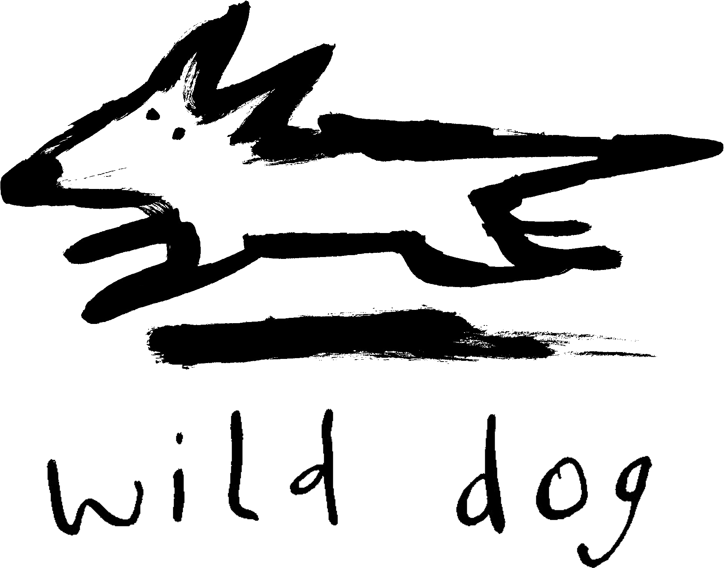

Wild Dog Books

Teachers’ Notes

Who? What? When? Where?
Why? & How?

Synopsis
Who, What, When, Where, Why, and How – also known as the five Ws and one H – are a series of questions that are critical to gathering information or solving problems. These questions are routinely asked by journalists, police investigators and scientists when trying to get the complete story on a given subject, incident or problem. By asking these questions, we open up our minds to a world of enquiry that is incredibly useful to our daily lives. Welcome to the curious and inquisitive world of Who? What? When? Where? Why? & How?
Writing style
Who? What? When? Where? Why? & How? has been designed with the needs of both early and more advanced readers in mind. Simple and succinct language is used throughout the book, with no more than a few sentences on each page. The large format images relate directly to the text, so young readers have multiple entry points to engage with the information. There is also a brief glossary in the back of the book, which will aid young readers in developing the tools of research and analysis.
Photographic/Design style
Who? What? When? Where? Why? & How? makes use of an elegant design set-up: on the left-hand-side is a single question, written in large text and set on a block colour backdrop (these colours naturally progress through the colour spectrum, which will appeal to visual readers). On the right-hand-side is a mixture of bright, full-page colour images and colour images set on stark white backdrops, which helps to isolate the text and further capture the imagination of the reader. The photographs bring the viewer close to the subject that is being discussed, and also have the advantage of being static, giving the reader the opportunity to explore the image and look at the subject matter and its features in detail. The photographs are strongly composed and clearly printed with bright strong colours to increase the appeal to visual readers, while also allowing readers to explore how photographs are used to convey messages.
Study notes
Themes:
- Questions
- Curiosity
- Creative thinking
- Critical thinking
- Looking at and questioning the world around us
Curriculum link: Literacy
Before reading Who? What? When? Where? Why? & How?:
- What is their first response when they look at the cover of the book?
- Brainstorm with the students about possible questions they might ask. For example, ‘Why is the sky blue?’ Ask them to think of questions they don’t know the answer to. The more unusual, the better!
While reading Who? What? When? Where? Why? & How?:
- Ask the students to take turns reading a paragraph aloud to the rest of the class. Where appropriate, ask the students what they think certain words may mean.
After reading Who? What? When? Where? Why? & How?:
- Ask the students to reflect on the words they would use to describe a tricky question, and the words that have been used in the book. Ask them to draw up a list of words that can be used to describe tricky questions.
Curriculum Theme: Critical and Creative Thinking
After reading Who? What? When? Where? Why? & How? ask the students the following questions:
- What is a question?
- What is an answer?
- Are some questions more difficult than others?
- Can their be more than one answer to a question?
- What makes a question difficult to answer?
- Did they already know the answer to any of the questions from the book?
- Which questions and answers did they find the most interesting/surprising?
Curriculum link: ICT Capability
After reading Who? What? When? Where? Why? & How?:
- Activity One:
- Organise the class into small groups. Assign each group a selection of riddles (for example, from http://frugalfun4boys.com/2015/05/31/30-riddles-brain-teasers-for-kids/ or http://www.everythingmom.com/parenting/45-riddles-and-brain-teasers-for-kids). The objective for each group is to answer their riddles without the help of the internet (though potentially with help form their teacher). Remind the groups that many riddles require creative thinking to find the answer.
- Once they have correctly (and quietly) answered their riddles, ask each group to look for and print images relating to each of the riddles and their answer. They are then to write down the riddles onto a poster and attach pictures relevant to each riddle. So that the answers aren’t given away, answer pictures are to be hidden under a flap. Each group will then take turns swapping their riddle posters and trying to answer each other’s riddles.
- Activity Two:
- Organise the class into small groups. Assign each group a mystery from the following website http://kids.mysterynet.com/solveit/. Using the five Ws and one H set of questions, ask each group to read and solve their mystery.
Curriculum Theme: Personal and Social Capability
After reading Who? What? When? Where? Why? & How?:
- Organise the class into two groups. In one group, ask the students to work as a team to construct a word finder puzzle. Ask each student to suggest an appropriate word taken from the book. (e.g. current, disorder, decibel etc.). Once completed, print copies for the other group to complete.
- In the second group, students should work as a team to create a trivia bingo game. Ask each student to suggest a fact they found surprising or interesting. Combine these bingo words into a game for the whole class.
Find out more
- http://www.everythingmom.com/parenting/45-riddles-and-brain-teasers-for-kids
- http://frugalfun4boys.com/2015/05/31/30-riddles-brain-teasers-for-kids/
- http://www.japantimes.co.jp/news/2013/09/06/world/science-health-world/sciences-great-unknowns-20-unsolved-questions/#.V8eY8rVECJY
- http://www.pitara.com/category/science-for-kids/5ws-and-h/
Marketing and promotion
Who? What? When? Where? Why? & How? is a one-off title, though it shares many elements with The Weird and Wonderful World of Words, The Gigantic Book of Genes and The Numbers Book. Future one-off titles are planned, such as, The Big Book of Antarctica, The Litter & Recycling Book and The Big Book of Pets.

