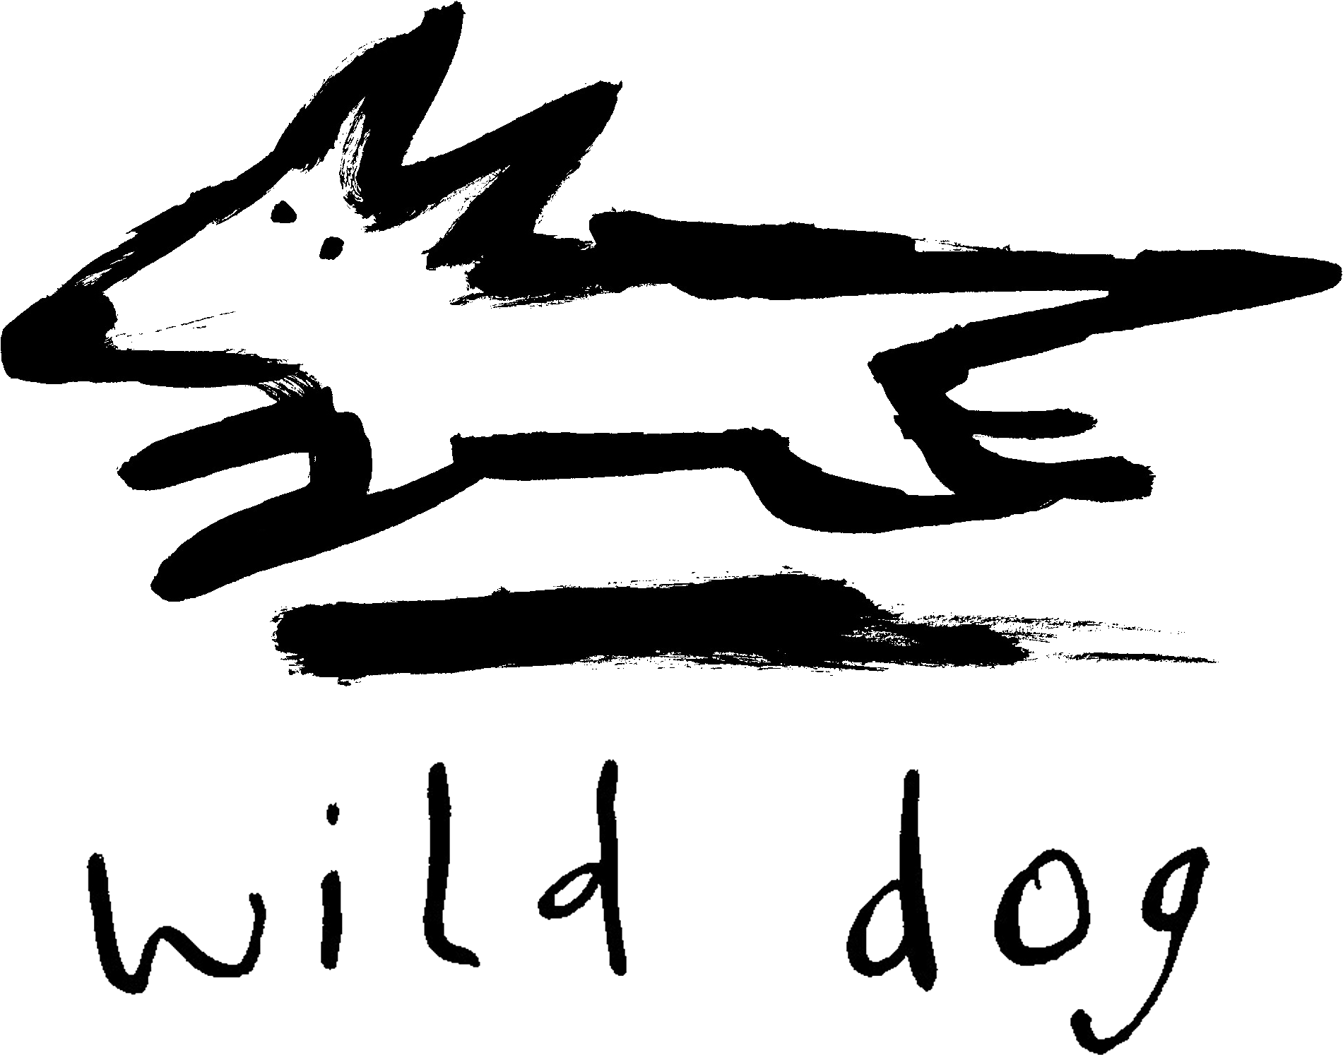

Wild Dog Books

Teachers’ Notes

Going To Antarctica

Synopsis
Antarctica is the continent located at the South Pole. It is a vast landmass covered in snow and ice. Nobody lives permanently in the Antarctica. There are no cities or towns. The only buildings are scientific research stations. Antarctica is surprisingly rich in animal life. Many birds and animals have adapted to these cold harsh conditions. Most animals live close to the edge of the continent, near the sea. The southern oceans are rich in microscopic life called krill and these tiny animals are the basis of many of the Antarctic food chains. Migration is one of the strategies that animals use to take advantage of this challenging environment. Find out all about how animals survive in Antarctica.
Writing style
The Going To series has been designed with the needs of very early readers and reluctant readers in mind. Text is succinct and simple, with no more than a few sentences on a page. The large format images relate directly to the text, so young readers have multiple entry points to engaging with the information. There is a brief glossary and Index in the back of the book, which will aid young readers in developing the tools of research and analysis.
Study notes
Themes:
- Climate and terrain
- Species
- Adaptation
- Habits and breeding
- Food, predators and prey
- Biodiversity
- Risk of endangerment
Curriculum link: Society and Environment
Before reading Going To Antarctica look at a world map and locate the South Pole. Ask the students to name the oceans that are surround Antarctica and to find the countries that are nearest. If possible, provide a template map of the globe looking down on the South Pole.
Brainstorm what students think the environments in Antarctica might be like. Ask them to make a list of what sort of animals they think might live in Antarctica, and what animals and birds would need to do to survive there.
Brainstorm what the students think scientists need to do to survive while staying in Antarctica. What sort of clothes do they need to wear? What sort of buildings do they need to live in?
Curriculum link: Science and Technology/Creative Arts
Divide the class into groups. Each group should select an animal that lives in Antarctica.
Students should create a visual project that can be presented to the whole class. The project should include an image or images of the selected animal, as well as answers to the following questions:
- Where in Antarctica it is it found?
- What type of habitat does it live in?
- What does it eat? What is its main prey?
- Where does it spend most of its time?
- How does it reproduce?
- Does it lay eggs? Where does it lay its eggs?
- Where does it have its babies?
- How many (approximately) are there in the wild? Is this animal endangered?
- Does the animal have any predators?
- How does the animal avoid being eaten by predators if there are any?
Ask the students to create a poster with a drawing of all of the animals that they have learnt about in this book. Under each image, ask them to list two facts they have learnt about this animal.
Play a game of ‘celebrity head’, labeling each student as a particular Antarctic animal from the book without showing the student which animal he or she is. Each student needs to try and guess which animal they are by asking questions of other students, for example, can I fly?
Marketing and promotion
Going To Antarctica is part of the Going To series, which includes titles such as Going To The Rainforest, Going To The Outback, Going To The Poles and Going To The Ocean.

